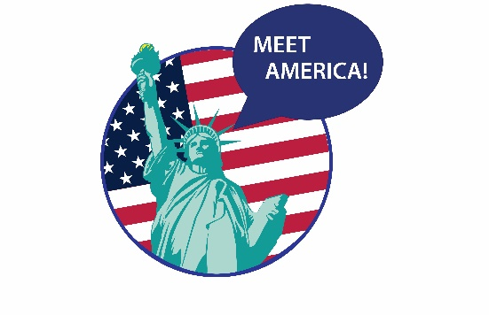
Meet America Program
U.S. Embassy Warsaw, U.S. Consulate General Kraków

Please provide the following information in order to request a meeting with a U.S. diplomat.

Name of the school or university (in Polish and English)
Name, surname of the meeting coordinator/moderator
Email, PHONE number of the meeting coordinator
From which faculty are the participating students?
What are the students class year? How old are they?
What topic/s are the students interested in? Please suggest a meeting title
Please suggest two options for the time and date for the event. The dates should not be earlier than 3 weeks before the event.
Other comments:

